**Air Quality Monitoring**

**Submitted by:Reddy Anusha**

**Reg.no:723921104021**

**E-mail I’d:anusharedddyk227@gmail.com**

**INNOVATION :**

Air quality monitoring is the process of measuring and assessing the quality of the air in a specific area to determine the concentration of various air pollutants and their impact on human health and the environment. This monitoring is crucial for several reasons:

1. **Health Protection:** Poor air quality can have severe health effects, such as respiratory problems, cardiovascular diseases, and even premature death. Monitoring helps identify areas with high pollutant levels, allowing for targeted interventions to protect public health.
2. **Environmental Impact:** Air pollution can harm ecosystems, damage vegetation, and contribute to climate change. Monitoring helps track pollutant levels and their effects on the environment.
3. **Compliance:** Many countries and regions have regulations and standards for air quality. Monitoring ensures that these standards are met, and it helps to identify sources of pollution that might be in violation of these regulations.
4. **Public Awareness:** Monitoring data can be made available to the public, raising awareness about air quality issues and encouraging people to take measures to reduce their exposure to air pollutants.
5. **Research and Policy Development:** Scientists and policymakers use air quality data to study trends, identify sources of pollution, and develop strategies to improve air quality. This includes implementing emission controls, urban planning, and clean energy policies.

Air quality is typically monitored for several key pollutants, including:

* **Particulate Matter (PM):** These are tiny particles or droplets in the air that can be inhaled into the lungs. PM2.5 (particles with a diameter of 2.5 micro meters or smaller) and PM10 (particles with a diameter of 10 micro meters or smaller) are common metrics.
* **Ground-Level Ozone (O3):** Ground-level ozone is a major component of smog and can have adverse health effects.
* **Nitrogen Dioxide (NO2):** This pollutant is produced by combustion processes and can irritate the lungs and lower resistance to respiratory infections.
* **Sulphur Dioxide (SO2):** SO2 is produced by burning fossil fuels and can irritate the respiratory system and contribute to acid rain.
* **Carbon Monoxide (CO):** CO is a color less, odor less gas produced by incomplete combustion of carbon-containing fuels.
* **Volatile Organic Compounds (VOCs):** These are a group of organic chemicals that can contribute to the formation of ground-level ozone and smog.

Air quality monitoring can be conducted using a network of monitoring stations that measure pollutant concentrations, and the data collected is often made available to the public in real-time through government agencies or environmental organizations. Additionally, advances in technology have led to the development of portable air quality monitors that individuals can use to assess air quality in their immediate surroundings.

Improving air quality requires a combination of regulatory measures, technological advancements, and public awareness to reduce emissions from sources such as industrial facilities, vehicles, and energy production.

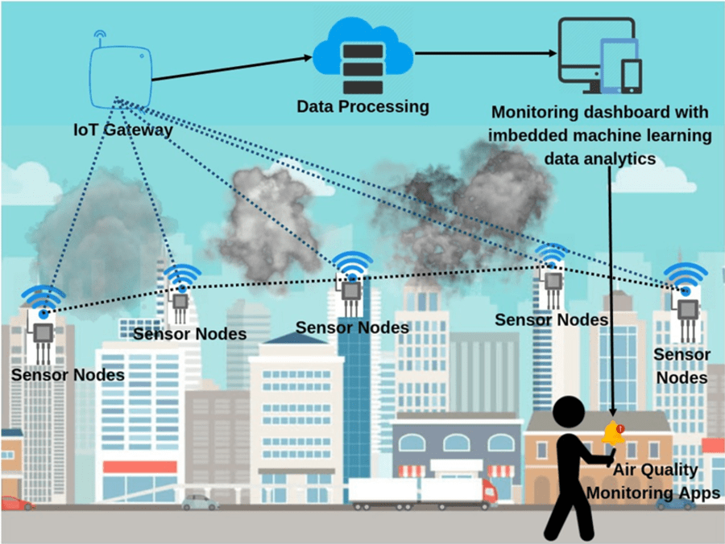

**what are the effects of AQM ?**

Air quality monitoring (AQM) has several important effects and benefits, both on the environment and public health:

1. **Improved Public Health:** Perhaps the most significant effect of AQM is the protection of public health. Monitoring air quality helps identify areas with high levels of air pollutants, allowing authorities to take measures to reduce exposure. This, in turn, can lead to a decrease in respiratory and cardiovascular diseases, such as asthma, bronchitis, and heart disease, and can ultimately save lives.
2. **Environmental Protection:** Monitoring air quality is crucial for protecting the environment. It helps identify sources of pollution and assess the impact of pollutants on ecosystems, including water bodies, forests, and wildlife. This information can guide environmental policies and regulations to mitigate pollution's effects on the natural world.
3. **Compliance with Regulations:** Many regions have air quality standards and regulations in place to limit the concentrations of certain pollutants in the air. AQM is essential for ensuring compliance with these standards. When air quality exceeds allowable limits, it can trigger actions like industrial emission reductions and traffic restrictions.
4. **Data for Research and Policy Development:** Air quality data collected through monitoring provides valuable information for scientific research and policy development. Researchers can use this data to study air pollution trends, assess the effectiveness of pollution control measures, and develop strategies to improve air quality. Policymakers can make informed decisions based on this data to enact regulations and programs aimed at reducing pollution.
5. **Public Awareness:** Making air quality data available to the public increases awareness of air pollution issues. This empowers individuals to take measures to protect themselves, such as avoiding outdoor activities during high pollution days or using air purifiers indoors.
6. **Urban Planning:** AQM data can influence urban planning decisions. For example, cities can use air quality information to optimize transportation routes, reduce emissions from construction projects, and promote the development of green spaces.

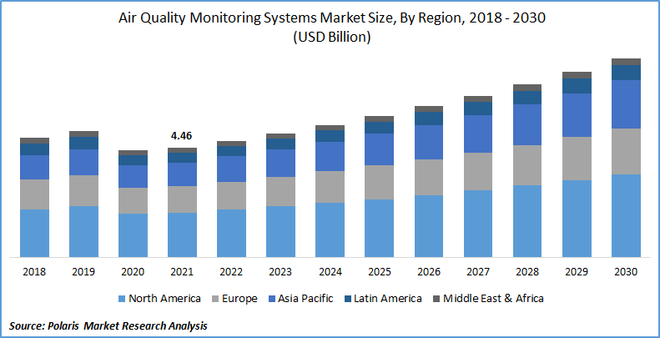

Overall, air quality monitoring plays a vital role in safeguarding public health, protecting the environment, and promoting sustainable, healthy communities. In conclusion, air quality monitoring (AQM) is a critical tool for safeguarding public health, protecting the environment, and promoting informed decision-making and actions to reduce air pollution.